**INTRODUCTION TO MATLAB**

**LAB # 01**



**Spring 2023**

**CSE301L Signals & Systems Lab**

Submitted by: **Ali Asghar**

Registration No. : **21PWCSE2059**

Class Section: **C**

“On my honor, as student of University of Engineering and Technology, I have neither given nor received unauthorized assistance on this academic work.”

Submitted to:

**Engr. Sumayyea Salahuddin**

Date:

**March 3, 2023**

**Department of Computer Systems Engineering**

**University of Engineering and Technology, Peshawar**

## Lab Objective(s):

Objectives of this Lab are;

* Introduction to MATLAB
* MATLAB Environment
* MATLAB Help
* Variable arithmetic
* Built in Mathematical Functions
* Input and display
* Timing functions
* Introduction to M‐files

## Task # 01:

1. Matlab stores numeric data as double‐precision floating-point by default. To store data as an 8‐ bit integer, int8 (a conversion function) can be used. Type the sample code in MatLab command window:

* x = 26
* whos
* y = int8(x)
* whos

What difference do you see? State your findings. (Also try uint16, uint32, uint64)

1. Take your name in the command window e.g. name = ‘Ali’. Convert it into 8‐bit integer format using the **int8** function.
2. Use the formatting commands present in MatLab to convert the system Clock to whole numbers rather than floating points.

### Code:

### Part a:

**Part b:**

**Part c:**

### Output:

### Task a:

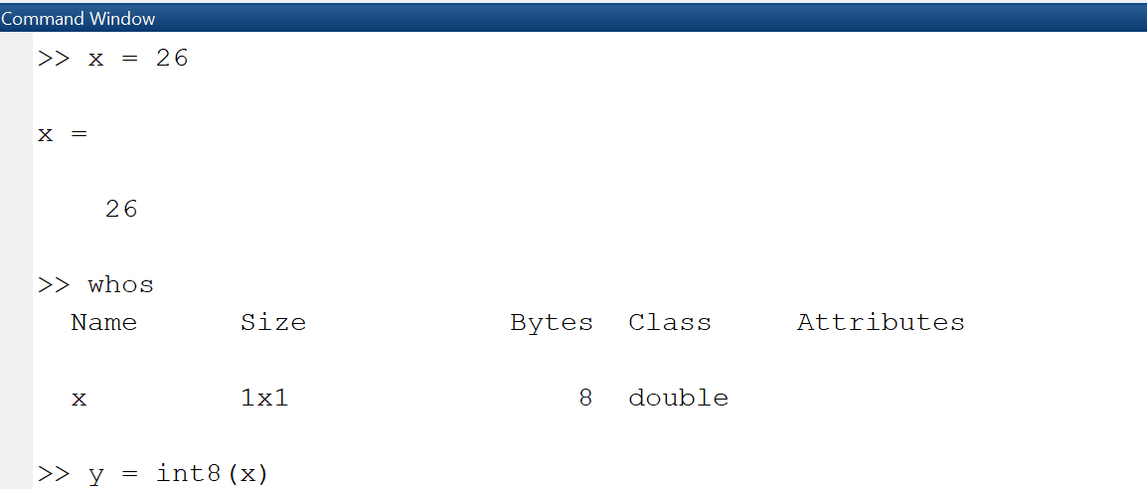

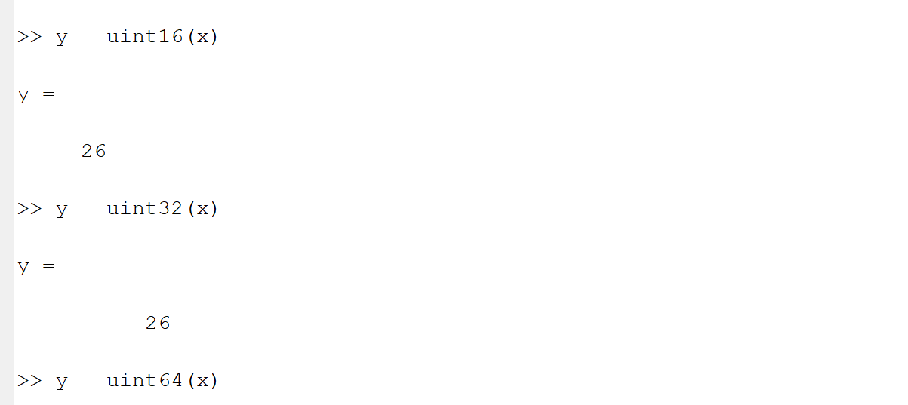

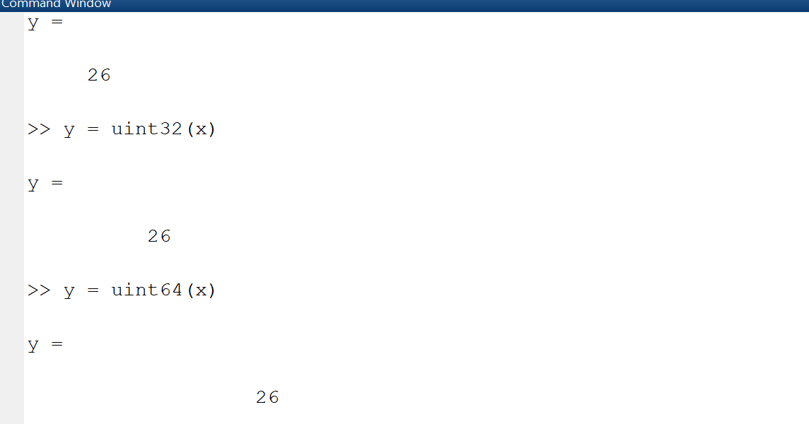

### 

### Task b:

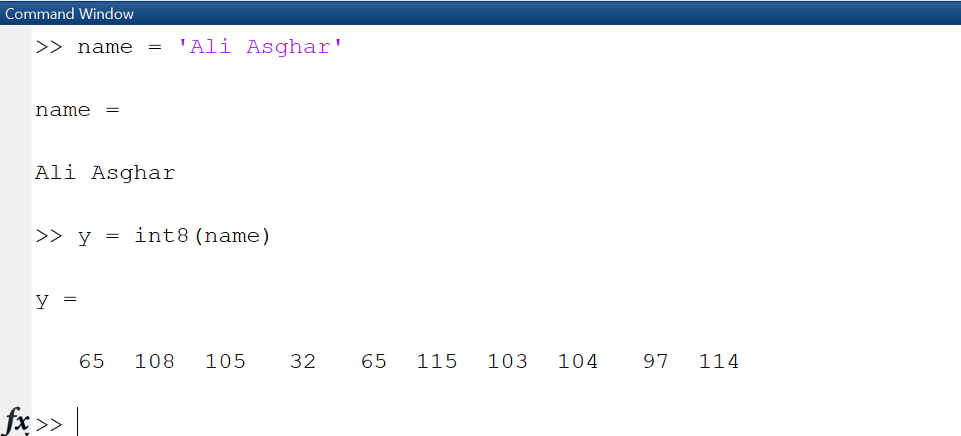

### Task c:

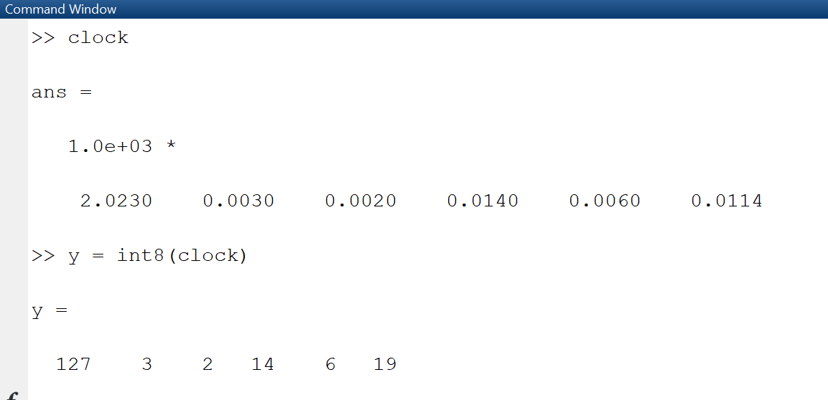

## Task # 02:

Create an M-File to prove any five expressions from the following:

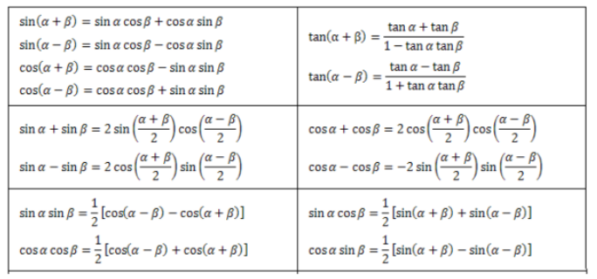

Use etime or tic toc functions to evaluate time taken for solving each of the five chosen

expressions.

### Code:

**Equation 1:**

**Equation 2:**

**Equation 3:**

**Equation 4:**

**Equation 5:**

### Output:

**Equation 1:**

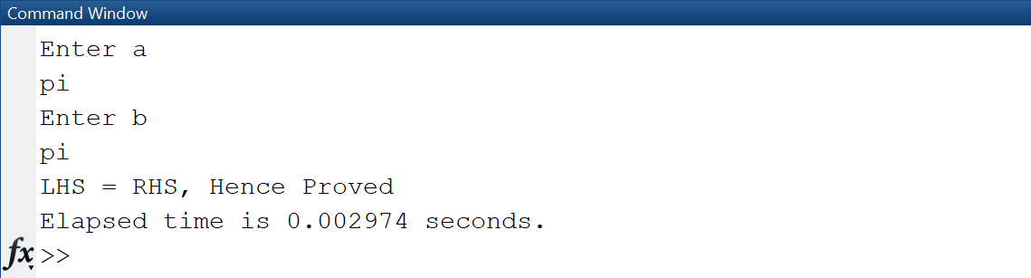

**Equation 2:**

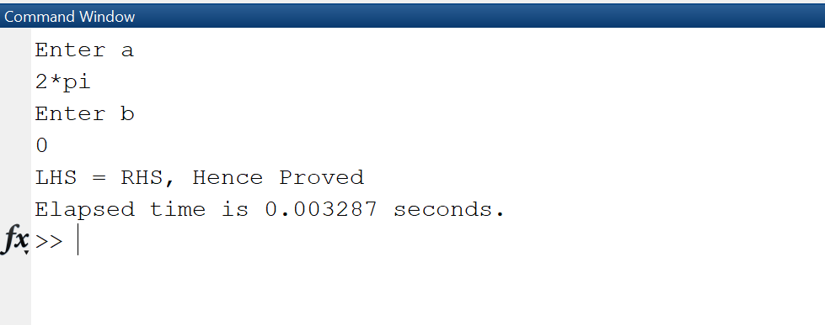

**Equation 3:**

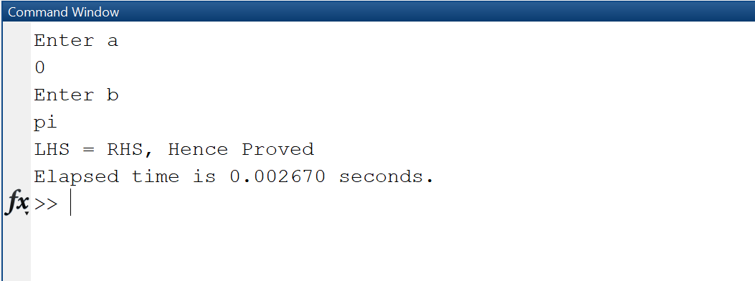

**Equation 4:**

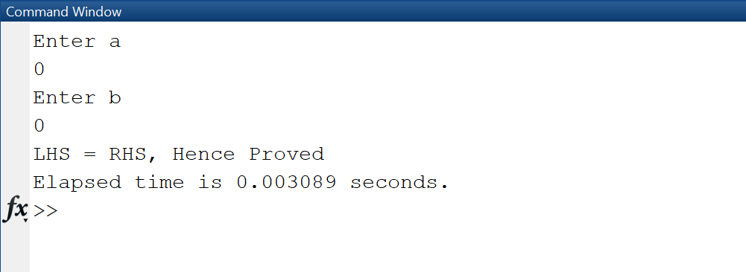

**Equation 5:**

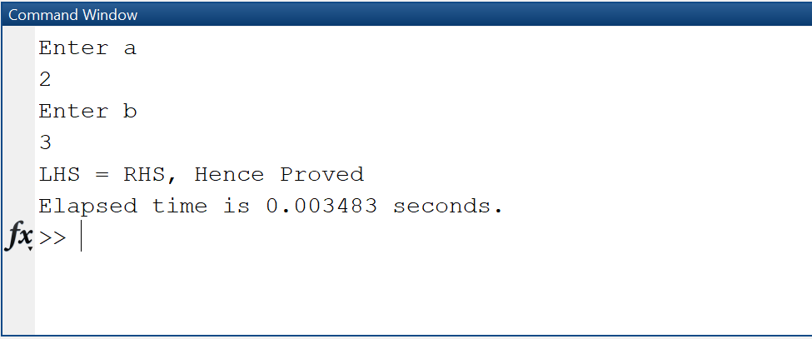

## Task # 03:

Write a CGPA Calculator program using M-File: Design a transcript for your second semester

result i.e. take grade points and credit hours of each subject as input from user and store in

variables. Take product of each subject grade points with its credit hours and divide by total

credit hours in order to evaluate CGPA. Show the results in the form of well designed transcript

using disp and input commands. Use the following table to display equivalent grades for each

grade point:

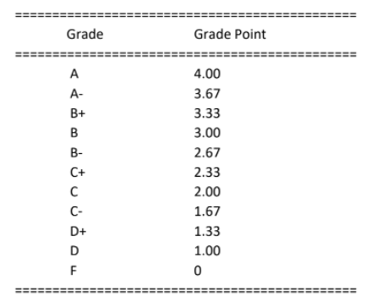

### Code:

### Output:

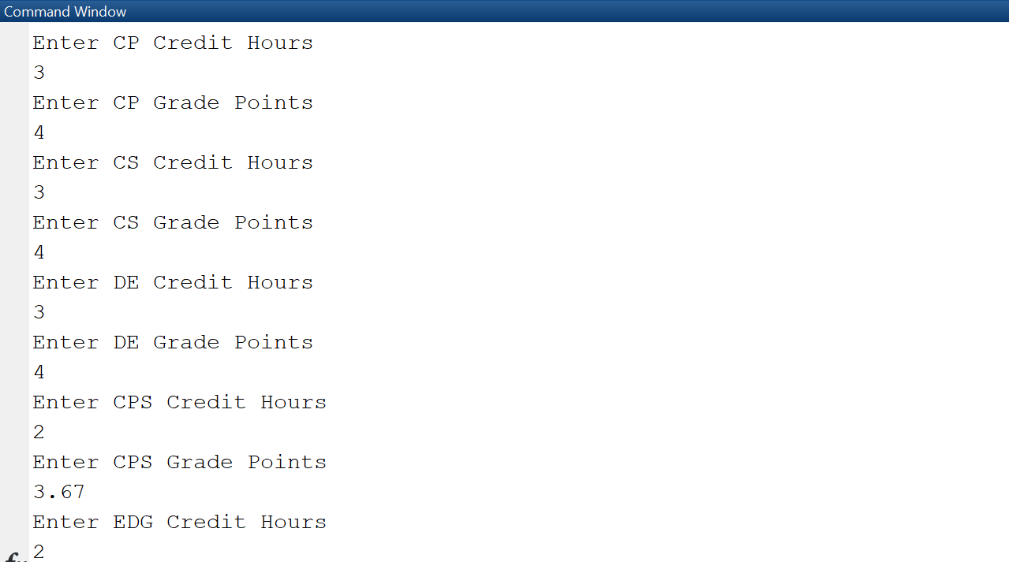

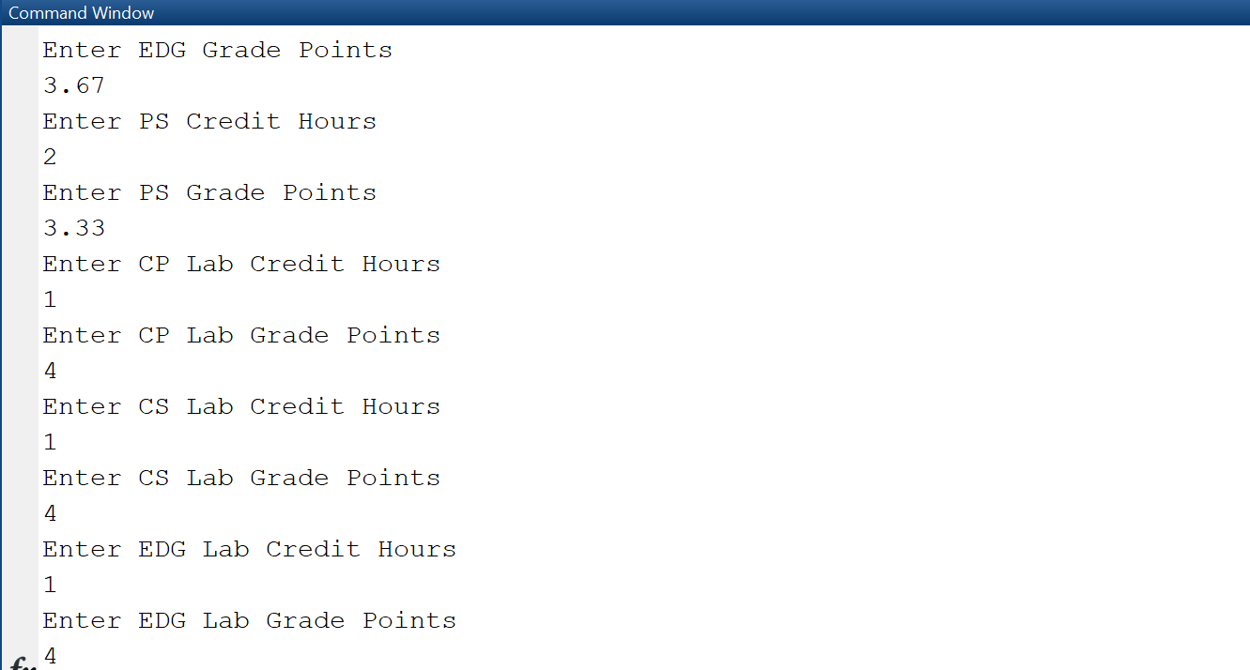

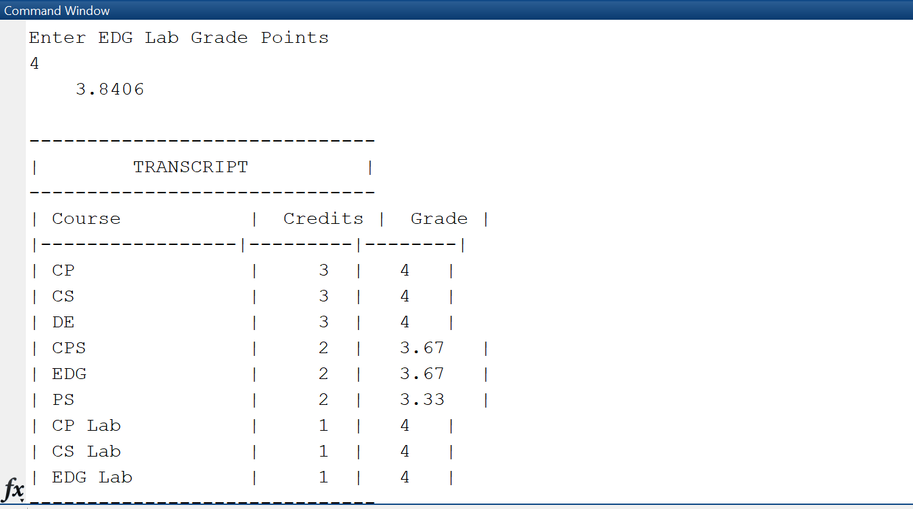

## 

## Task # 04:

Write a simple code to swap the values of two variables of double type using M-file. Create the

logic in such a way that no third variable is used. Show the etime for this code.

### Code:

### Output:

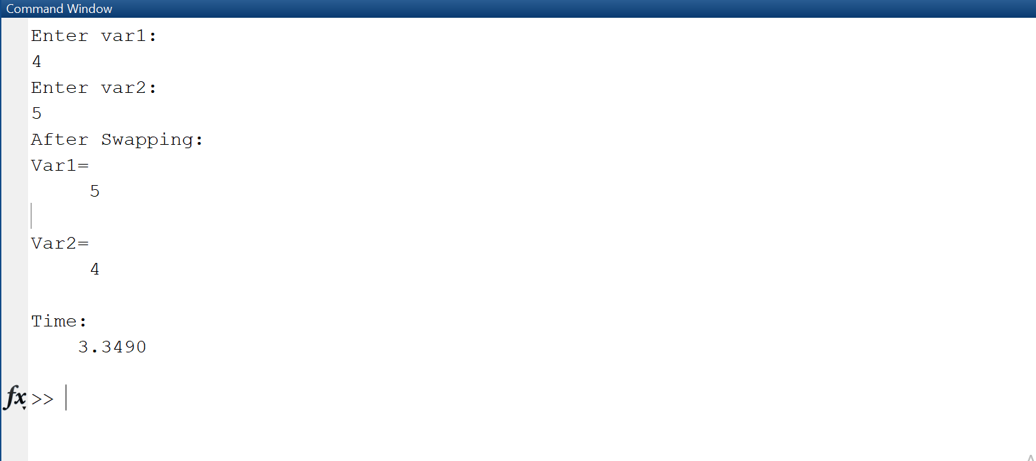

## Task # 05:

Implement the Pythagoras theorem in MatLab that takes input from the user.

### Code:

### Output:

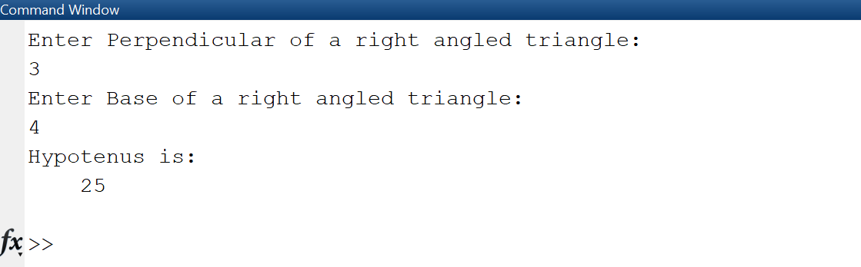

## Task # 06:

Implement a temperature conversion scenario in MatLab that takes the temperature from the user in Fahrenheit and displays the output in Centigrade.

### Code:

### Output:

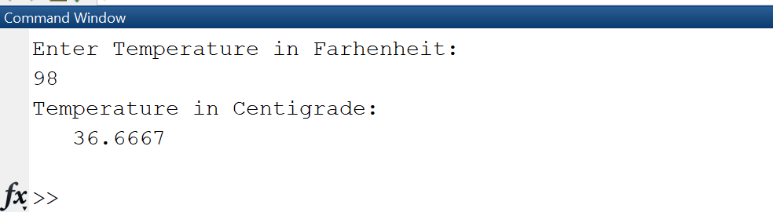

## Task # 07:

Devise an algorithm in MatLab that takes ten inputs from the user and normalizes them between [0-1]. Hints: Find the pair-wise max (maxi) and min (mini) of ten numbers using the max and min built-in command. Find the normalized value for each input using formula **(input-mini)/(maxi-mini).** Note: Do not use loops or if else structures.

### Code:

### Output:

